Web JDBC資料庫 Delete & Transaction
前置作業必須先完成: Web JDBC資料庫 Select文件內容
1. 修改index.jsp
<%@page contentType="text/html" pageEncoding="UTF-8"%>
<!DOCTYPE html>
<html>
<head>
<meta http-equiv="Content-Type" content="text/html; charset=UTF-8">
<title>JSP Page</title>
</head>
<body>
<h1>JDBC</h1>
<a href="/WebAppJDBC/SelectSupplier">讀取 Supplier 資料</a><br/>
<a href="/WebAppJDBC/UpdateCoffee.html">修改咖啡資料</a><br/>
<a href="/WebAppJDBC/InsertCoffee.html">新增咖啡資料</a><br/>
<a href="/WebAppJDBC/DeleteCoffee.html">刪除咖啡資料</a><br/>
</body>
</html>
2.新增: DeleteCoffee.html
<!DOCTYPE html>
<html>
<head>
<title></title>
<meta http-equiv="Content-Type" content="text/html; charset=UTF-8">
</head>
<body>
<form action="DeleteCoffee" method="post">
咖啡名稱:<input type="text" name="coffee" value="Extra Espresso"/><br/>
<input type="submit" value="Send"/>
</form>
</body>
</html>
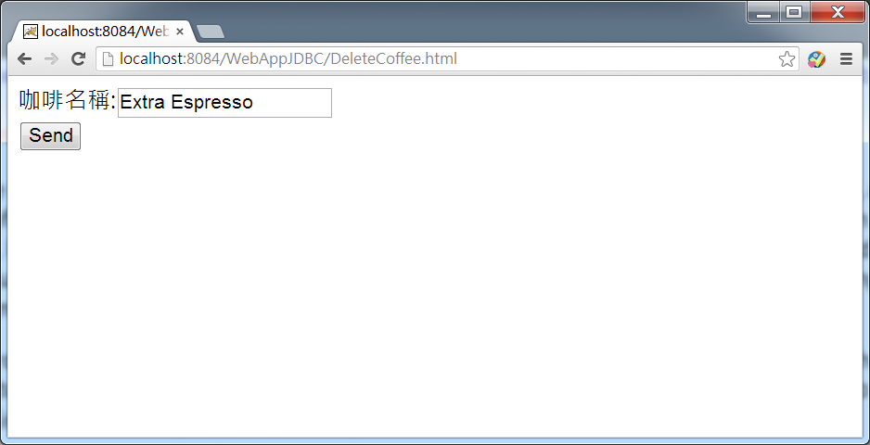
3.新增Servlet java程式DeleteCoffee.java

import java.io.IOException;
import java.io.PrintWriter;
import java.sql.Connection;
import java.sql.DriverManager;
import java.sql.PreparedStatement;
import java.sql.SQLException;
import javax.servlet.ServletException;
import javax.servlet.annotation.WebServlet;
import javax.servlet.http.HttpServlet;
import javax.servlet.http.HttpServletRequest;
import javax.servlet.http.HttpServletResponse;

@WebServlet(urlPatterns = {"/DeleteCoffee"})
public class DeleteCoffee extends HttpServlet {

protected void processRequest(HttpServletRequest request, HttpServletResponse response)
throws ServletException, IOException {
response.setContentType("text/html;charset=UTF-8");
PrintWriter out = response.getWriter();
try {
/* TODO output your page here. You may use following sample code. */
out.println("<!DOCTYPE html>");
out.println("<html>");
out.println("<head>");
out.println("<title>Servlet InsertCoffee</title>");
out.println("</head>");
out.println("<body>");
String coffee=request.getParameter("coffee");

try {
DeleteCoffee(coffee);
} catch (SQLException ex) {
System.out.println(ex.getMessage());
}
out.println("刪除完成");
out.println("</body>");
out.println("</html>");
} finally {
out.close();
}
}
public void DeleteCoffee(String coffee) throws SQLException {
Connection con=null;
PreparedStatement delete= null;

String insertStatement =
"delete from COFFEES " +
"where COF_NAME=? ";

try {

Class.forName("com.mysql.cj.jdbc.Driver");
con = DriverManager.getConnection("jdbc:mysql://localhost:3306/classicmodels?useUnicode=true&characterEncoding=utf8&serverTimezone=CST","root","1234");

con.setAutoCommit(false);
delete = con.prepareStatement(insertStatement);

//for (Map.Entry<String, Integer> e : salesForWeek.entrySet()) { }
delete.setString(1, coffee);
delete.executeUpdate();
con.commit();

} catch (Exception e ) {
System.out.println(e.getMessage());
if (con != null) {
try {
System.err.print("Transaction is being rolled back");
con.rollback();
} catch(SQLException ex) {
System.out.println(ex.getMessage());
}
}
} finally {
if (delete != null) {
delete.close();
}
if (delete != null) {
delete.close();
}
con.setAutoCommit(true);
}
}
@Override
protected void doGet(HttpServletRequest request, HttpServletResponse response)
throws ServletException, IOException {
processRequest(request, response);
}

@Override
protected void doPost(HttpServletRequest request, HttpServletResponse response)
throws ServletException, IOException {
processRequest(request, response);
}

@Override
public String getServletInfo() {
return "Short description";
}// </editor-fold>
}
PS>最後請同學加入程式讀取新增後的Coffee表格資料

